**System Test Procedure Specification**

* 1. **Test Case Specification Identifier**

TPS-01-02 2014-05-22

* 1. **Purpose**

This procedure describes the steps necessary to perform the test specified in the test design specification for PlasmaGraph feature “Import Data” and “Create Graph” **[see *SRS-3-2014-05-15 section 2.2.1.1 and 2.2.1.4*]**.

* 1. **Special requirements**

This test must be executed in 5 minutes or less.

* 1. **Procedure steps**

1. ***Execute PlasmaGraph***

In order to launch the application the tester must click on the PlasmaGraph icon.

1. ***Import the data file provided into PlasmaGrap***

To import the data file provided the tester have to click on the data option located in the top menu of the tool bar. After doing this a menu with two more options will appear. Click on “Import Data”.

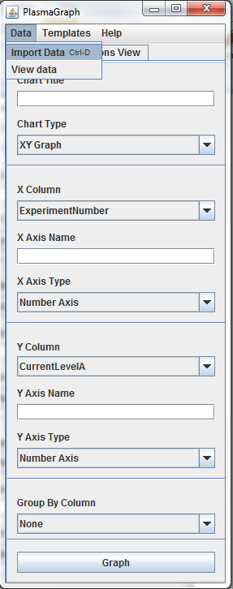

1. ***Select data set for the X axis***

To choose which data is going to be represented in the X axis the tester must click on the X column option located in the tool bar. The column to be used for the X axis in this test case is Temperature2eV.

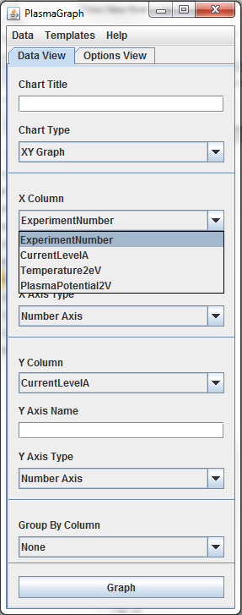

1. ***Select data set for the Y axis***

To choose which data is going to be represented in the X axis the tester must click on the X column option located in the tool bar. The column to be used for the X axis in this test case is PlasmaPotential2V.

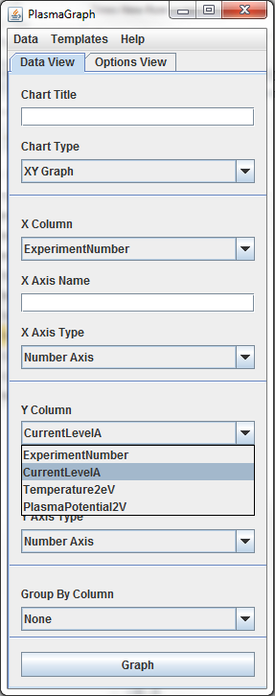

1. ***Create Graph***

To create the graph click on the “Graph” button located in the tool bar.

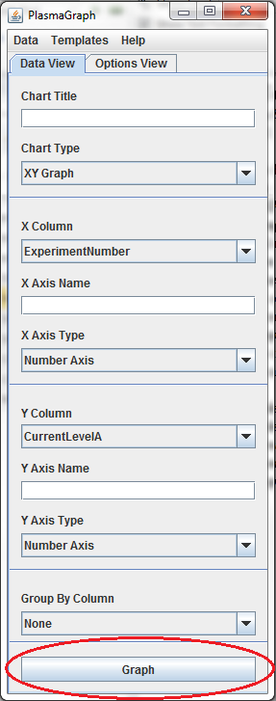

1. ***Compare outputs***

The tester must examine the graph produced by the program and determine if it complies with the expected output specified in the test case specification for this case ***[see document TCS-01-02 section 4]***.

1. ***Repeat for other OS***

Repeat steps 4.1 through 4.7 under the following operative systems:

1. Windows 7
2. Ubuntu Linux 14
3. Mac OS X 10